Lab 7 Customizations

Hands-on lab Step-by-Step

September 2021

# Lab Overview and Pre-requisites

This beginner-level lab gives you hands-on experience designing and developing a virtual agent, customer voice and adding images to sub grid in Model Driven Apps.

Here’s what you’ll learn:

* **Customer Voice:** Create survey to be sent after completing case from chatbot.

# Exercise 1: Create survey and send it to customer after case completed

## Task 1: Create New Survey

To create a new survey, follow these steps:

1. Go to [Dynamics 365 Customer Voice](https://customervoice.microsoft.com/) and sign in with your credentials.
2. Select **All Projects** from the navigation menu.

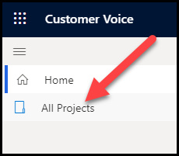

1. Select New Project. Choose Support as template and click Next.

1. Choose your environment for Survey location and click **Select and close** and **Create.**

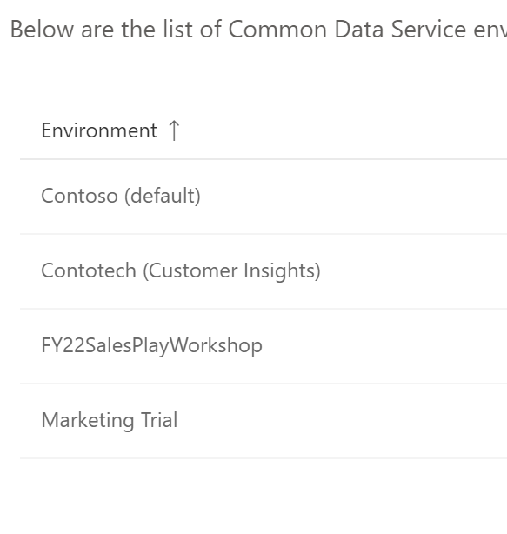

1. The project will open, and the existing default survey for that project will be displayed. Select **New survey**.

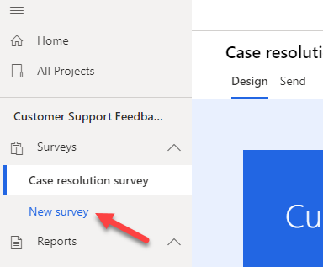

1. After the survey has been created, select the ellipsis (**...**) next to the new survey and then select **Rename**.

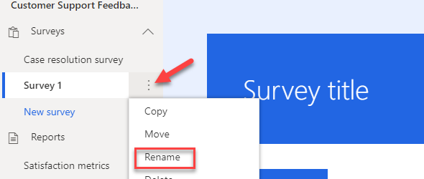

1. Enter **Premium Support Survey** as the new name and then select **Rename**.

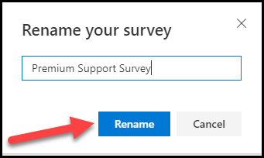

1. Select the **New Survey** title.

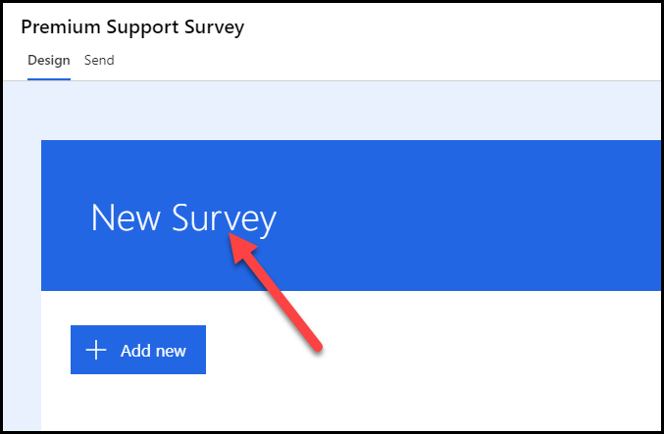

1. Enter **Case Resolution Survey** as a **Title**.
2. Select **+ Add new**.

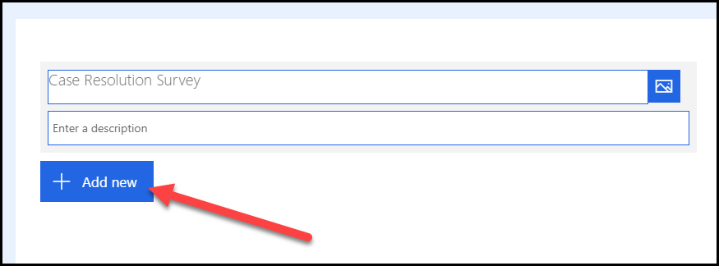

1. Select the **More** button.

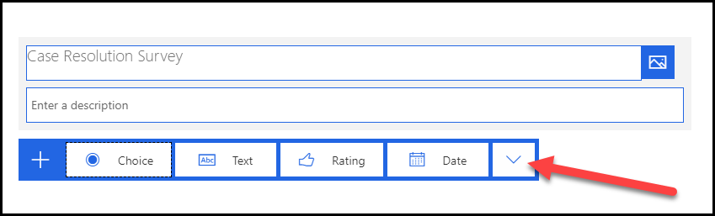

1. You should see all survey question types that are available to you. Select **Rating**.

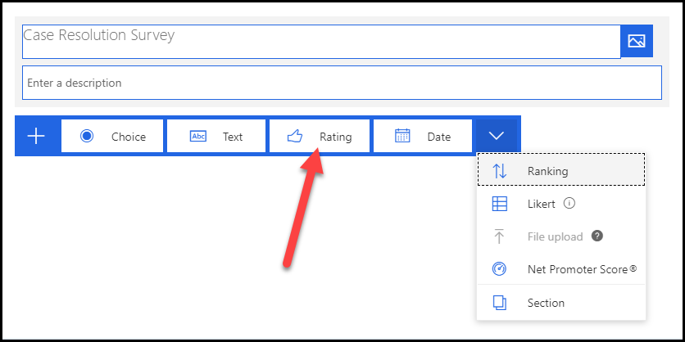

1. Enter **Overall, how happy were you with how your case was handled?** for a question and then select **Smiley** for the **Symbol**.

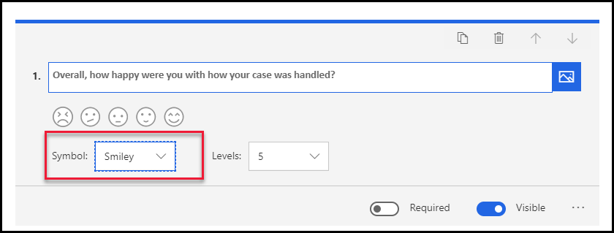

1. Select **+ Add new** again.
2. Select the **More** button and then select **Likert**.

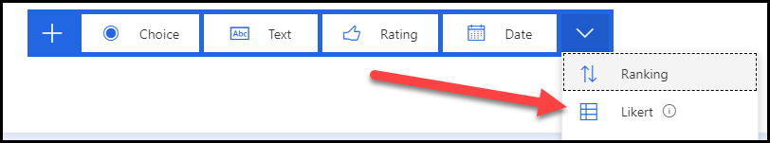

1. Enter **Do you agree or disagree with the following statements:** for a question and then change **Option 1** to **Strongly disagree**.

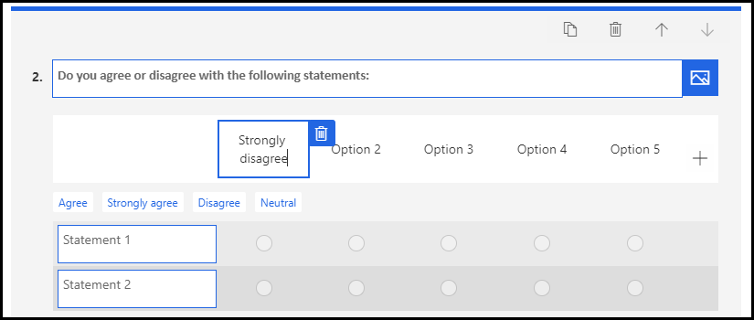

1. Replace **Option 2** with **Somewhat disagree**, **Option 3** with **Neither agree nor disagree**, **Option 4** with **Somewhat agree**, and **Option 5** with **Strongly agree**. Your options should now look like the following image.

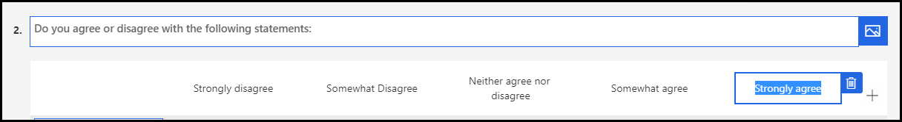

1. Select **Statement 1** and enter **The support rep was knowledgeable**.
2. Select **Statement 2** and enter **The case was responded to in a timely manner**.
3. Select **+ Add statement**.

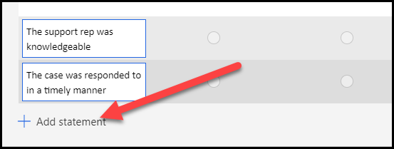

1. Enter **The support technician was courteous and helpful**.
2. Select **+ Add statement**.
3. Enter **I didn't have to wait more than 5 minutes to get call backs**.
4. Select **+ Add statement** one more time.
5. Enter **Contoso Inc. has excellent customer service**. Your statements should now look like the following image.

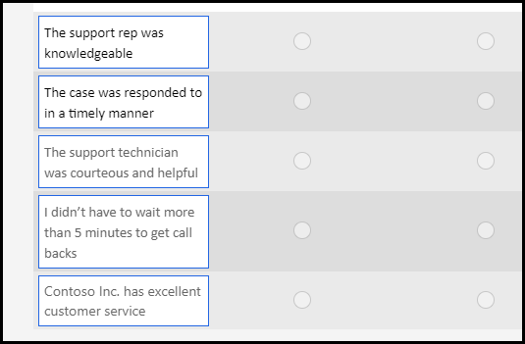

1. Select **+ Add new**.
2. Select **Text**.
3. Enter **Please tell us about your experience with our support team** for a question and select **Long answer**.

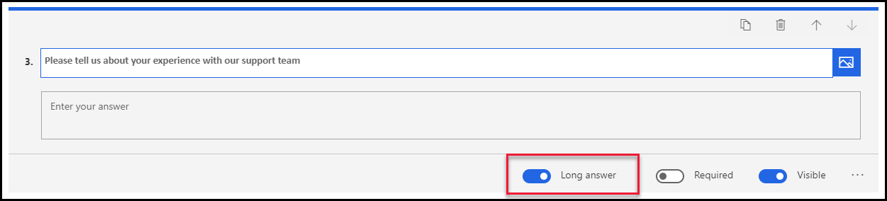

1. Select **+ Add new** again.
2. Select the **More** button and then select **Net Promoter Score**.

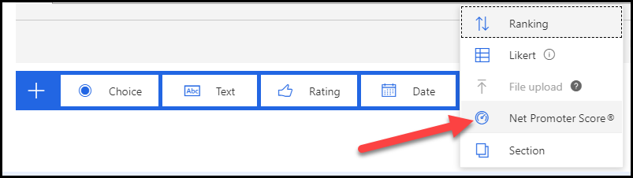

1. Enter **How satisfied were you with our case resolution process?** for a question.
2. Change the lowest rating to **Not satisfied at all** and the highest to **Very satisfied**.

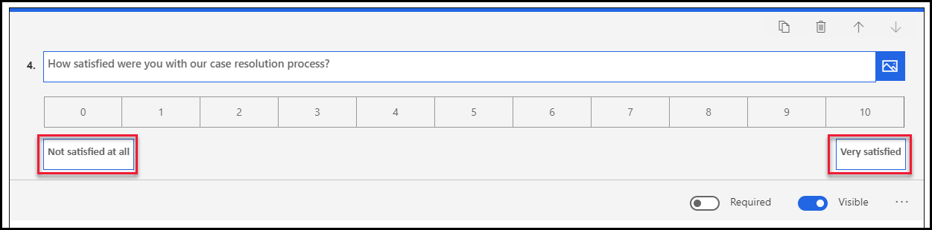

1. Select **Preview**.

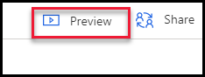

1. Review your survey and then select the **Back** button. You may now close the form editor.

## Task 2: Test the survey

In this task, you will test your survey by sending it to yourself in an email message.

1. Select the **Send** tab from the top of your survey.

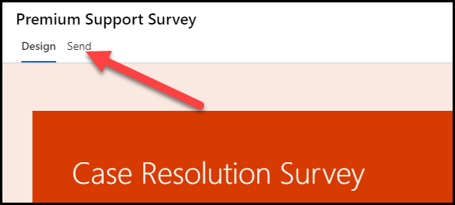

1. Select the **Customization** menu and then select **Distribution settings**.

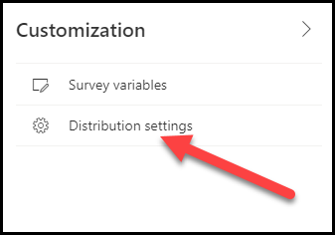

1. From the **Distribution settings** screen, select **Participants**.

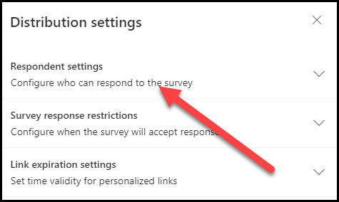

1. Make sure that the **Only people in my organization can respond** and the **Anonymize responses** settings are turned off.

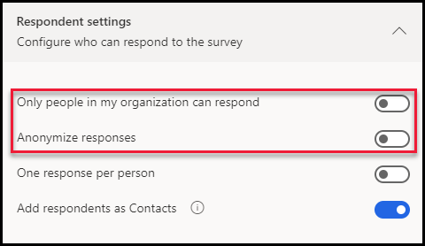

1. Select **Email** from the options on the **Send** tab.

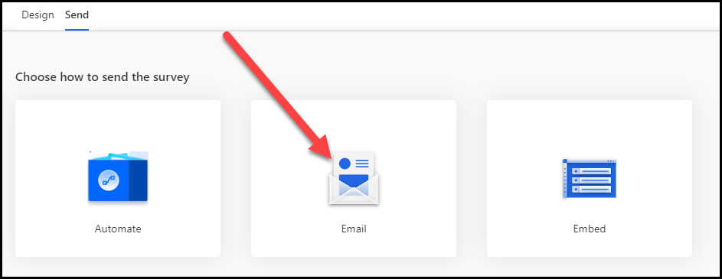

1. Provide your organization **Email Address** for **Recipients** and then select **Send**. The first name and last name of the user will only be available to your survey if at least one of the following statements is true for the email that you provided.
   1. It is a contact in Outlook.
   2. It is related to a record in your Dynamics environment.
   3. It is someone who is part of the same organization.

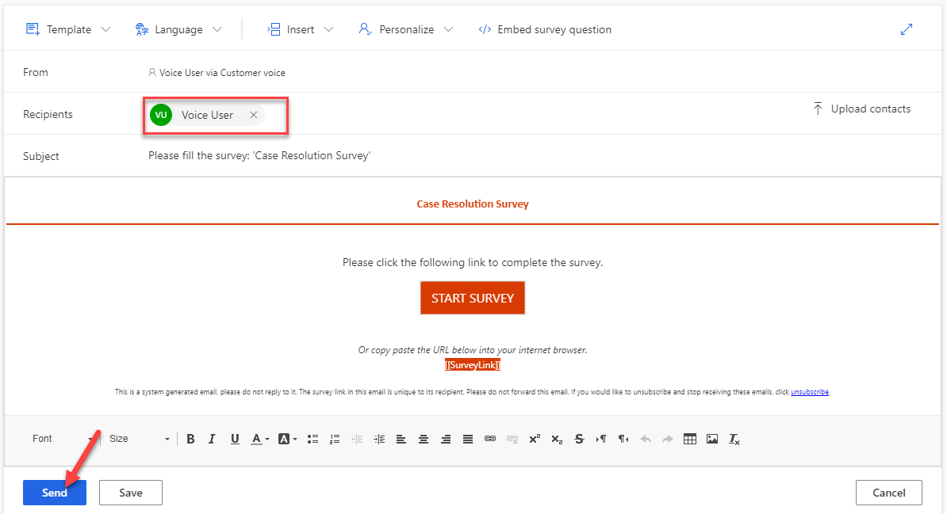

1. The survey will be sent.

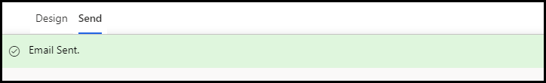

1. Go to your email, locate the survey email, and open it. Check your junk mail if you don't see it in your inbox.
2. Select **Start Survey**.



The survey should load, and your name should show in the description.

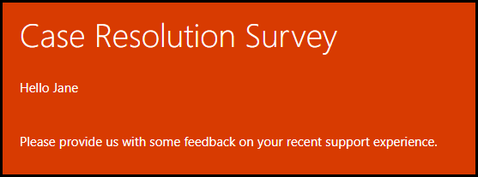

1. Provide a rating and answer the Likert questions.

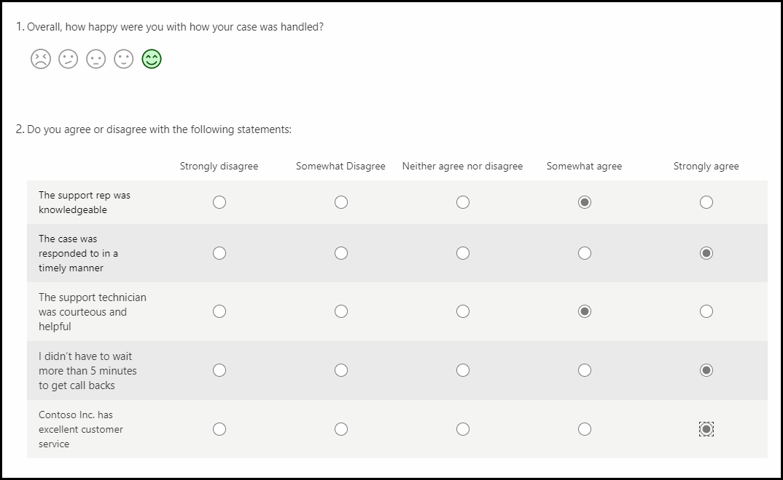

1. Provide a comment and select **7** for satisfaction. The last question should stay hidden.

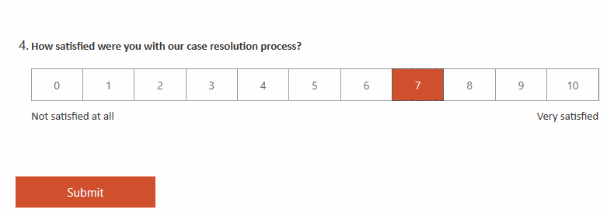

1. Change the satisfaction rating to **6**. The last question should now appear.

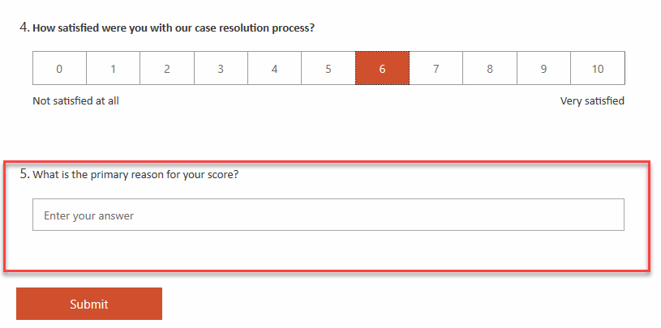

1. Change the rating to **8**. The last question should become hidden again.
2. Select **Submit**.

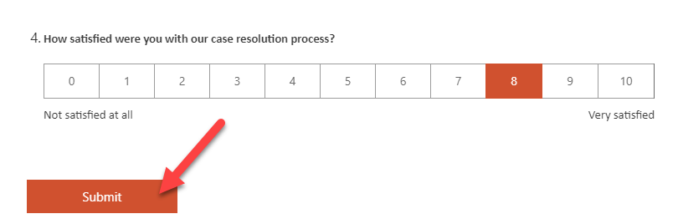

1. Wait for the survey submission to be completed.

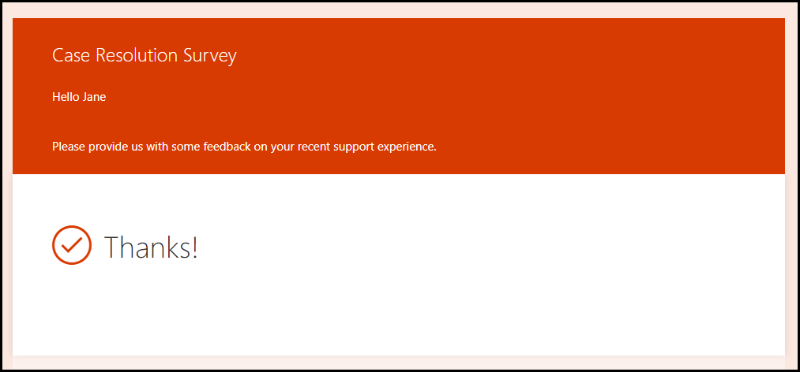

## Task 3: Select a Power Automate template

In this task, you will use Power Automate to send the survey that you created in the Work with Dynamics 365 Customer Voice projects module.

1. Go to [Customer Voice](https://customervoice.microsoft.com/) and sign in with your credentials.
2. Select the environment where you have Dynamics 365 Customer Engagement installed. The Dynamics 365 Customer Voice survey should have been created in the same environment.
3. Locate the Customer Support Feedback project that you created previously and select its name.

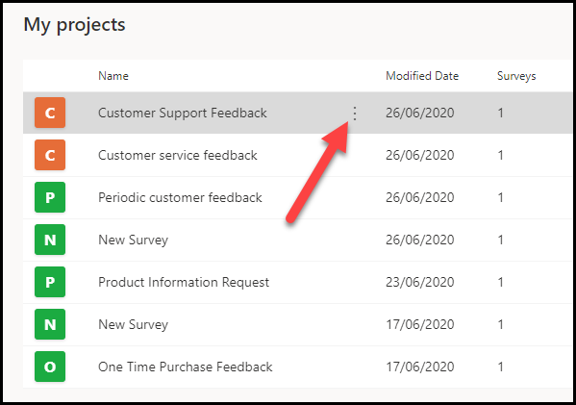

1. Select the **Premium Support Survey** that was created previously and then select the **Send** tab.

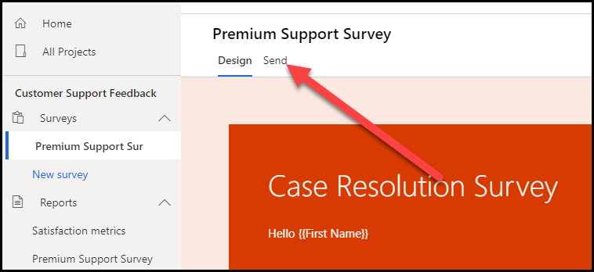

1. Select **Automate**.

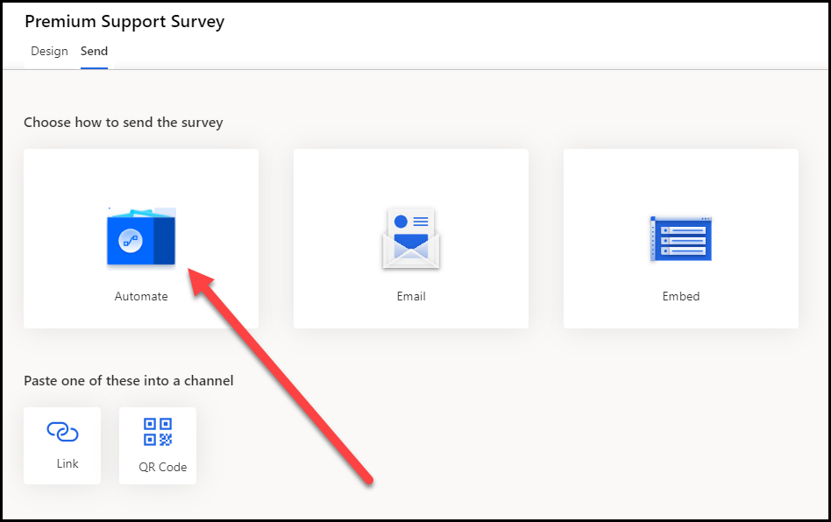

1. Select **Send a survey when a case is resolved in Dynamics 365**.

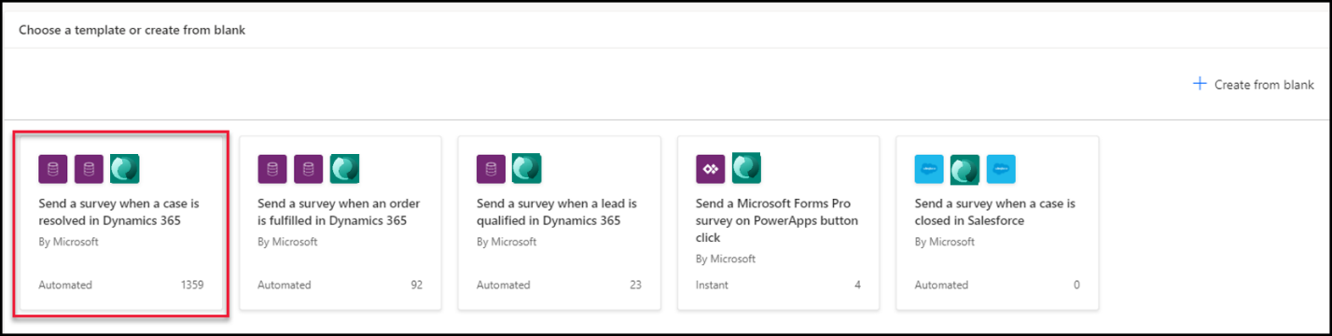

1. Follow the subsequent steps if this is your first time creating a flow. If you are not prompted to select a region, move on to the next step.

a. Select your **Country/Region** and then select **Get started**, if prompted.

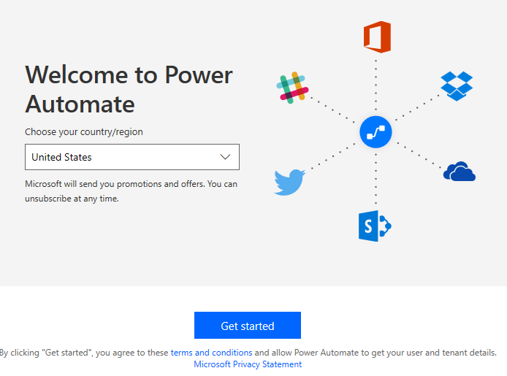

b. Select **Sign in** or **Update**, if prompted to sign in to your Microsoft Forms environment.

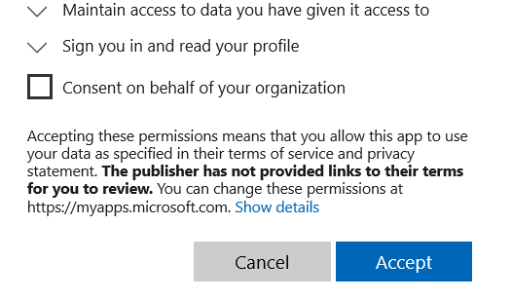

c. Select **Accept**.

d. Select **Continue**.

1. If you see the following screen (depending on if this is the first time you've signed in), select **Try it now**.

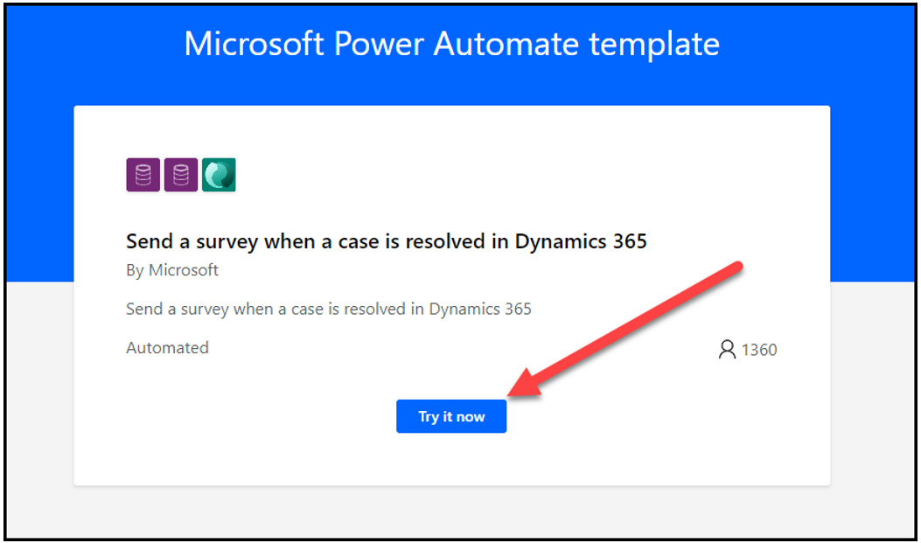

1. Select the environment where you have Dynamics 365 Customer Engagement installed and then select **Create**.

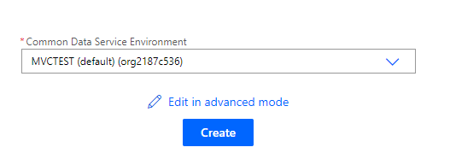

The flow will open in a new tab.

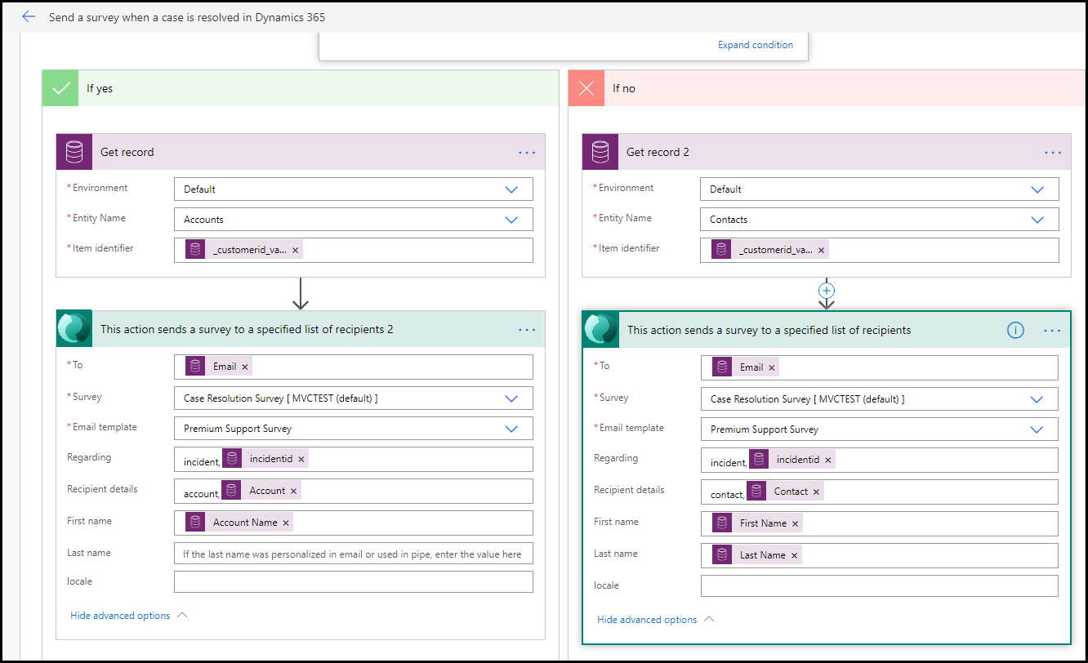

1. Do not navigate away from this page.

## Task 4: Examine and edit the flow

In this task, you will examine the flow that was created by the template and add a filter to the trigger. This filter will ensure that the flow is triggered only when the **Status Reason** column changes instead of running on every change that is made to the case record.

1. You should already be in edit mode for the flow that was created in Task 1. If not, and you are viewing the **Details** screen for the flow, select **Edit**.

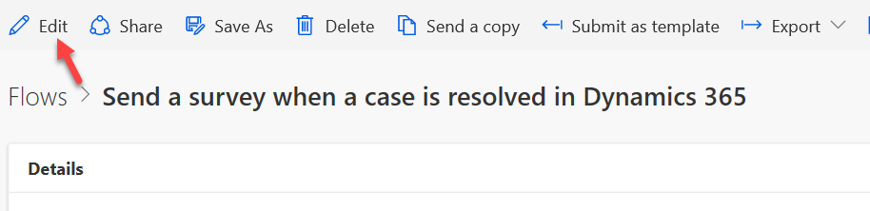

1. The flow should open in edit mode. Expand the trigger by selecting the header.

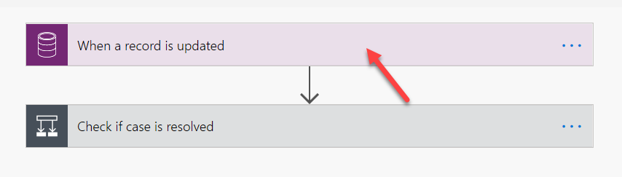

1. Select **Show advanced options**.

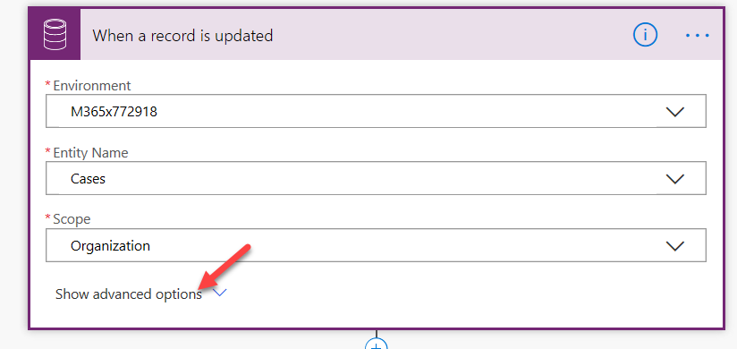

1. Select **status code** for **Attribute filter**. This action will make sure that the flow is triggered only when the status of the case changes.

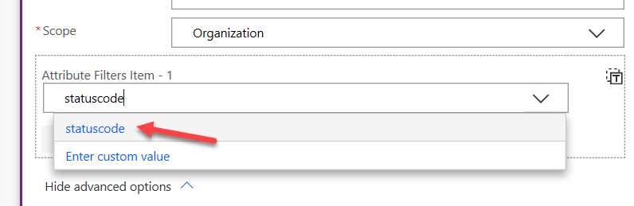

1. Select **Hide advanced options**.

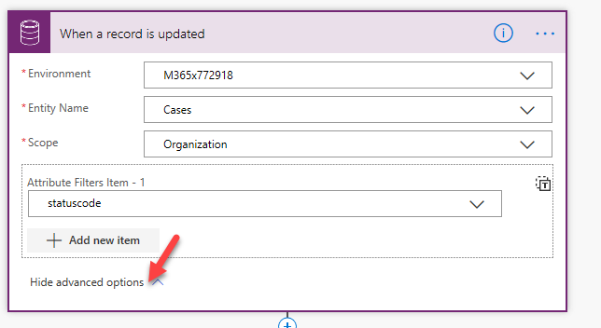

1. Collapse the trigger by selecting the header again.
2. Expand the condition.

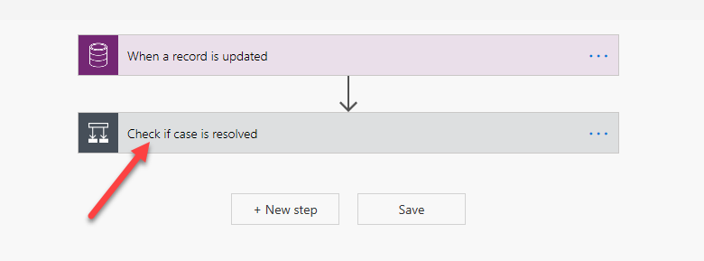

1. Select **Expand condition**.

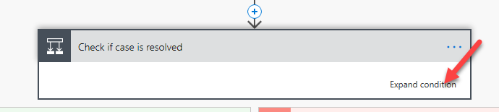

The first condition checks if the **Status Reason** value is **5** (Resolved).

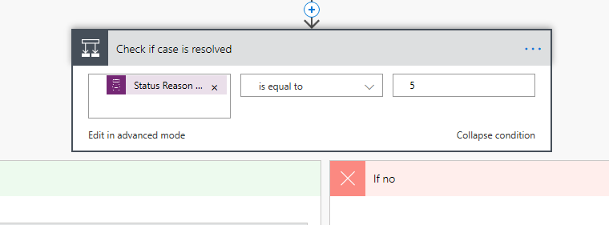

1. You will only take actions if the case was resolved. Expand the condition inside the **If yes** branch.

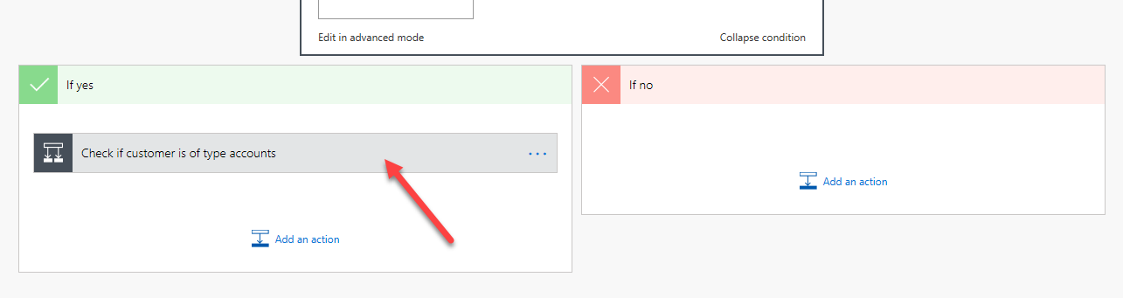

1. Select **Expand condition**.

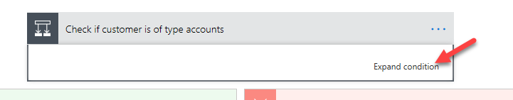

This condition checks if the customer type of the case is an account.

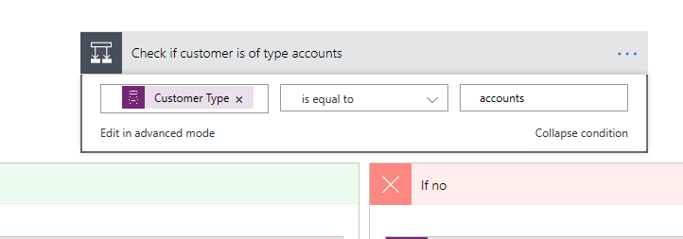

1. Evaluate both branches of the flow (you are not making changes, just viewing what has been created).

If the customer type of the case is an account:

* + The flow will get the account record.
  + Add the **Send survey** action.
  + Use the information from the prior actions to fill out the send survey columns.
  + Select the correct survey and email template.

If the customer type of the case is not an account:

* + The flow will get the contact record.
  + Add the **Send survey** action.
  + Use the information from the prior actions to fill out the send survey columns.
  + Select the correct survey and email template.



1. Collapse all actions and then select **Save**.

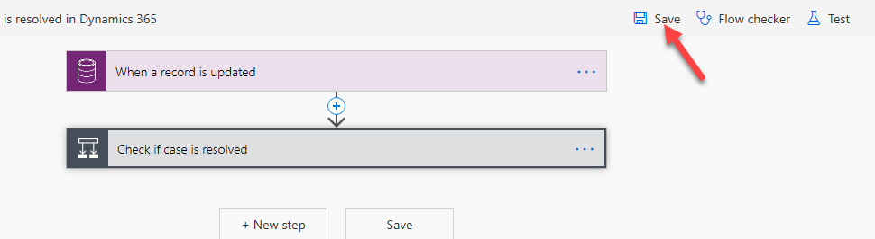

1. Do not navigate away from this page.

## Task 5: Test the flow

In this task, you will test the flow and see what the flow will send to the customer.

1. Start a new browser tab and navigate to your Dynamics 365 Sales Hub application.

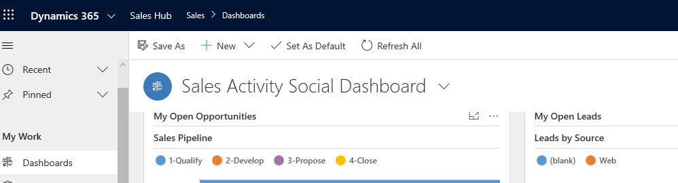

1. Select **Cases**.

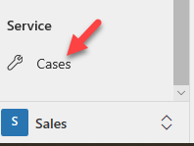

1. Select **+ New**.

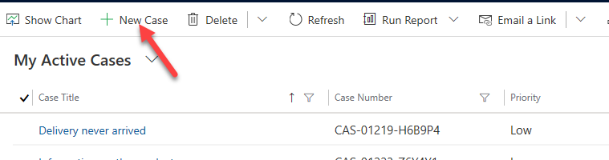

1. Enter **Missing parts** for **Case Title**, select the **Customer** column, and then select **+ New Record**.

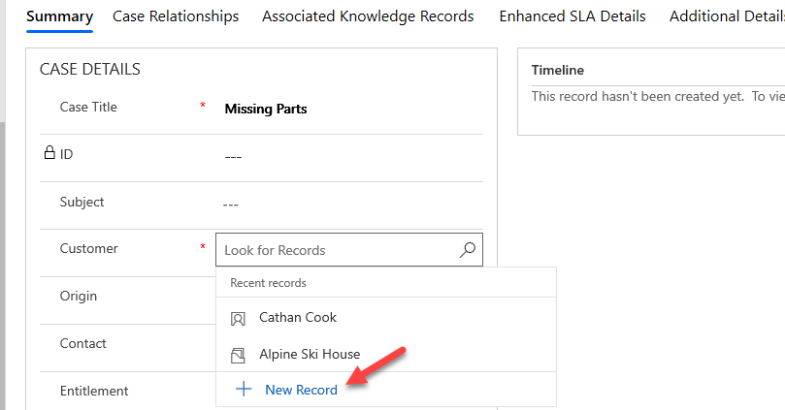

1. Select **Contacts**.

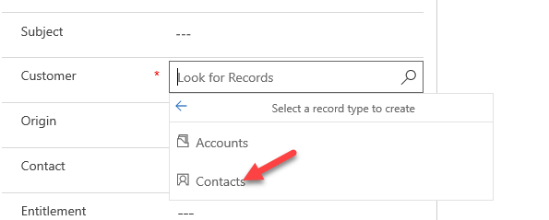

1. Provide the first name, last name, and your organization user's email.

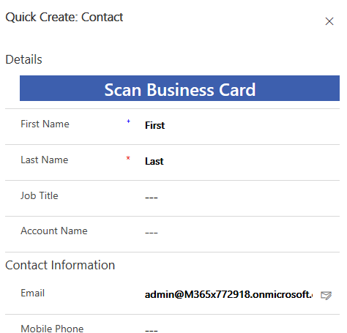

1. Select **Save and Close** to save the form.
2. Select **Save** to save the case record.

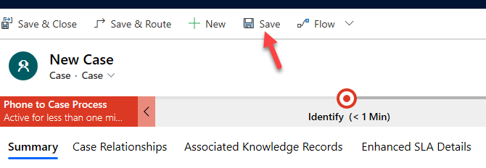

1. Select **Resolve Case**.

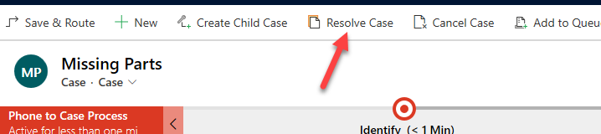

1. Enter **Sent replacement** for **Resolution**, select **15 minutes** for **Billable Time**, and then select **Resolve**.

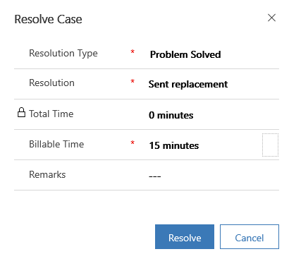

1. Go to Power Automate and select the back button.

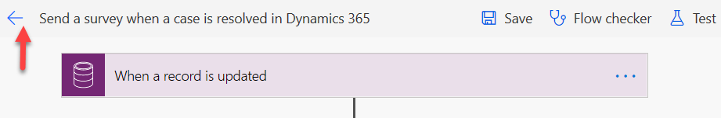

1. You should have at least one flow run, and it should have succeeded. Select to open the run.

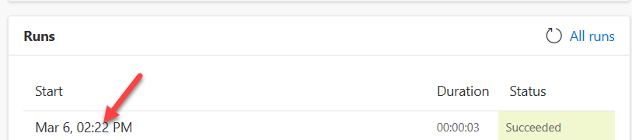

Your flow should take the **If no** path and run successfully.

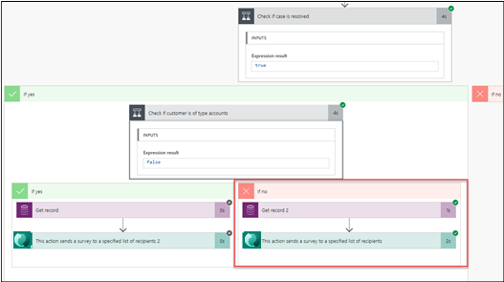

1. Start a new browser tab/window.
2. Go to [Outlook](https://outlook.com/) and sign in with your credentials.

You should receive an email similar to the following image.

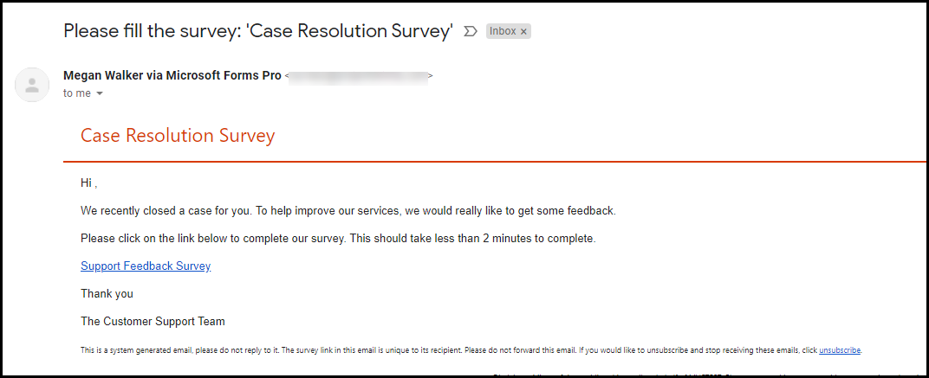

1. Select **Start Survey**.

The survey should open.

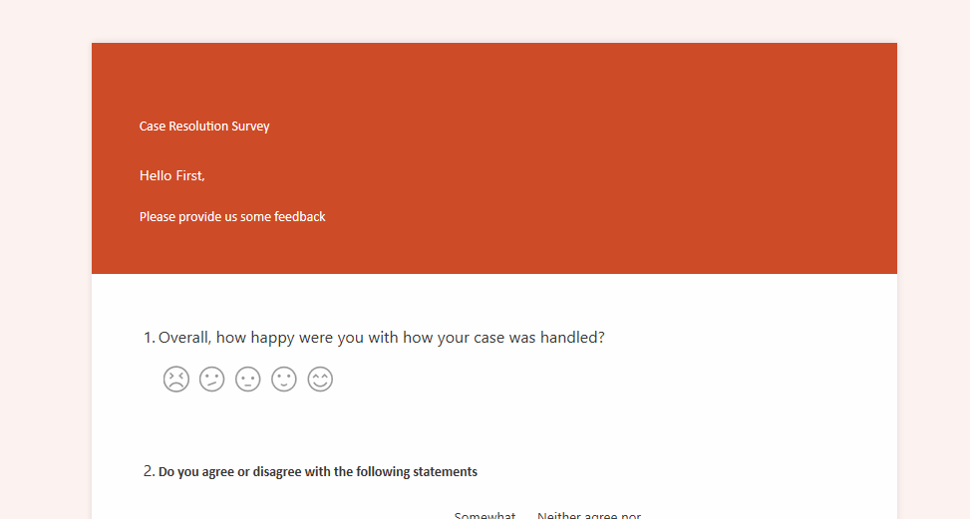

1. Close the survey browser window or tab.
2. Return to the case and select **Reactivate Case**.

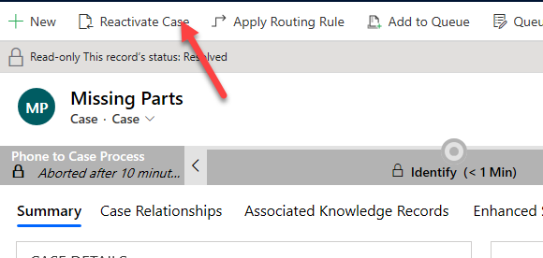

1. Select **Reactivate** to confirm.

## Task 6: Replace the Send survey action

In this task, you will delete the **Send survey** action that came with the Power Automate template and replace it with **Create invitation** action.

1. Return to the flow in Power Automate that was created in Task 1.
2. Select **Edit**.

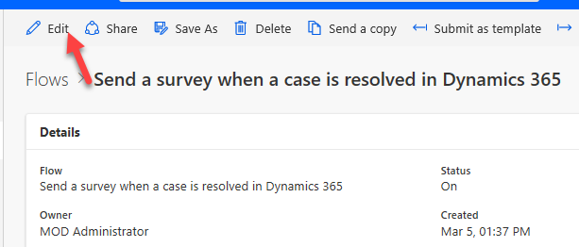

1. Expand the conditions and select the ellipsis (**...**) button of the **Send survey** action located in the **If no** branch.

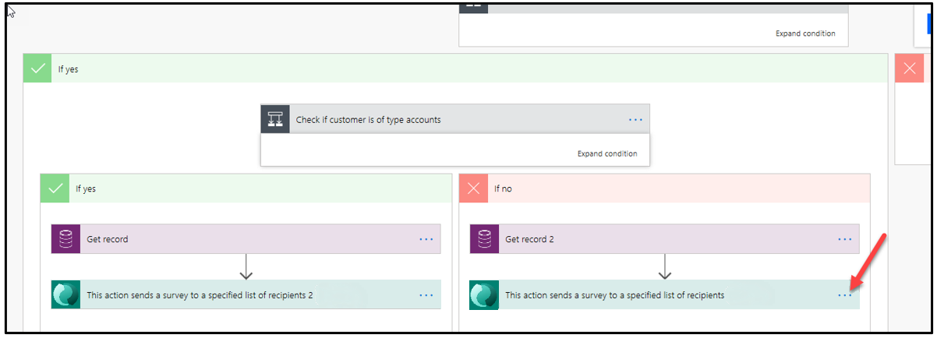

1. Select **Delete**.

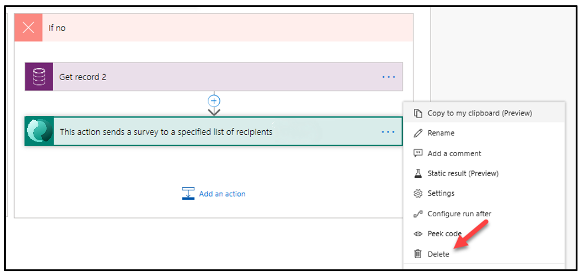

1. Select **OK**.
2. It is a good idea to name your flow actions. Select the ellipsis (**...**) button of **Get record 2** and then select **Rename**.

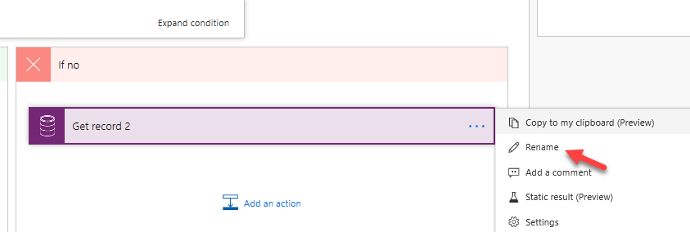

1. Rename the action **Get contact**.

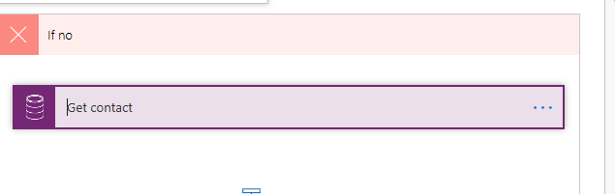

1. Select **Add an action**.

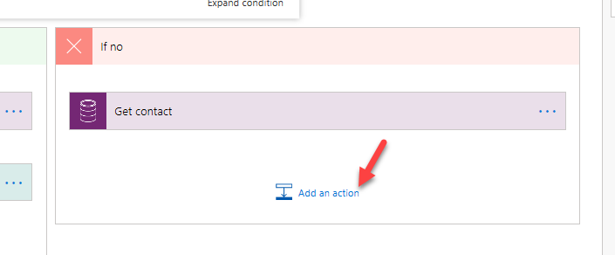

1. Search for **invitation** and select **Create an invitation**.
2. Rename the invitation **Create contact invitation**.

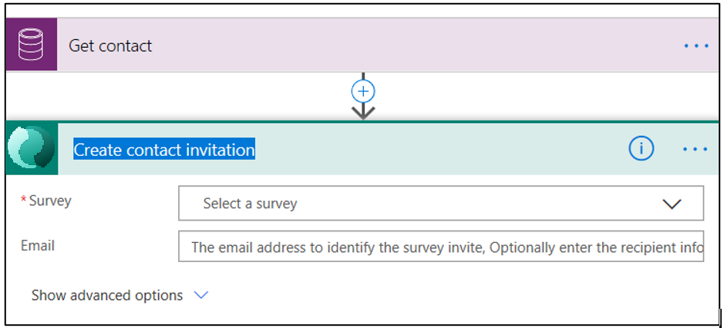

1. Select **Case Resolution Survey** for **Survey** and select the **Email** column.

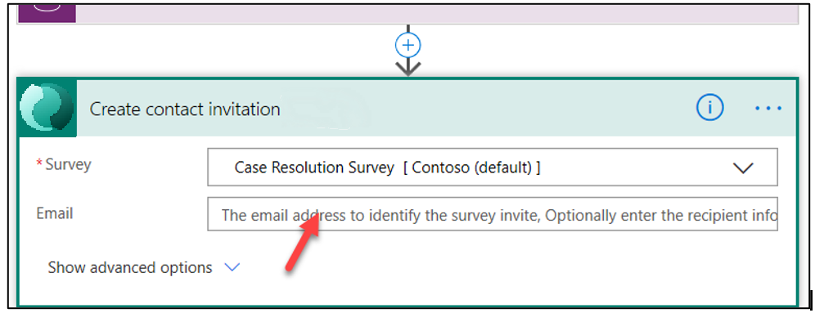

1. Search for **email** and select **Email** from the **Get contact** action.

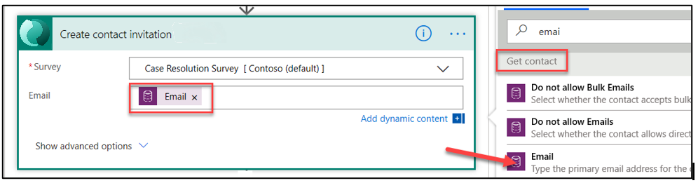

1. Select **Show advanced options**.

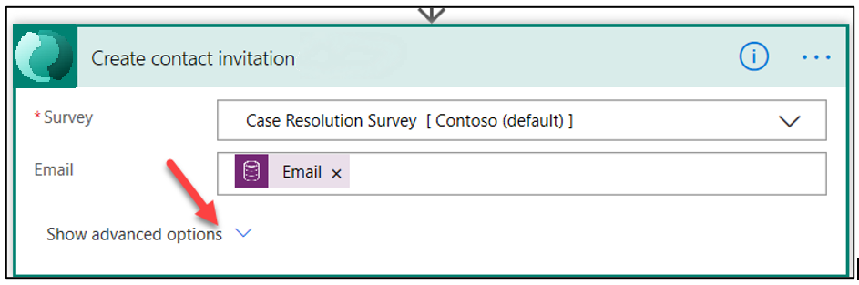

1. Select the **First Name** column and select **First Name** from the **Dynamic content** pane.

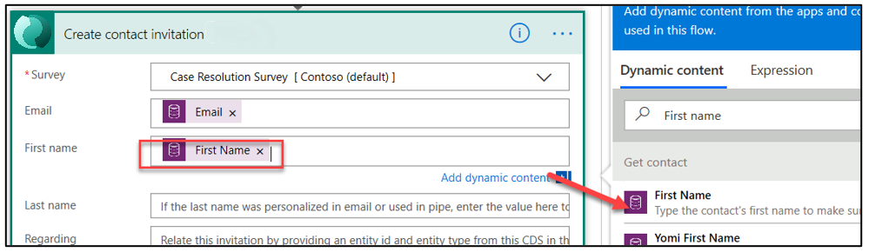

1. Select the **Last Name** column and select **Last Name** from the **Dynamic content** pane.

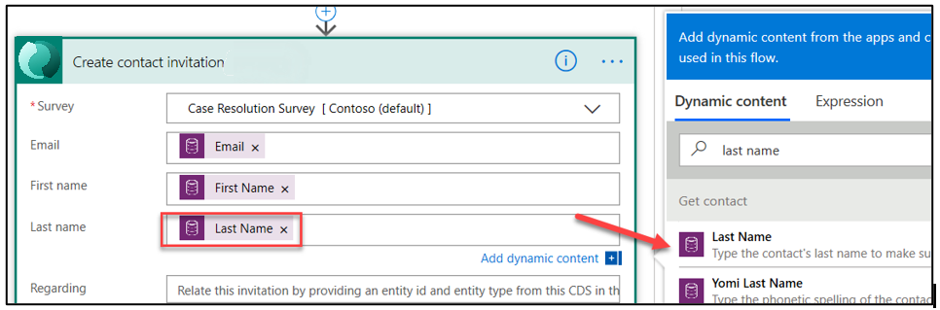

1. Type **Incident** in the **Regarding** column and select **Case** from the **Dynamic content** pane.

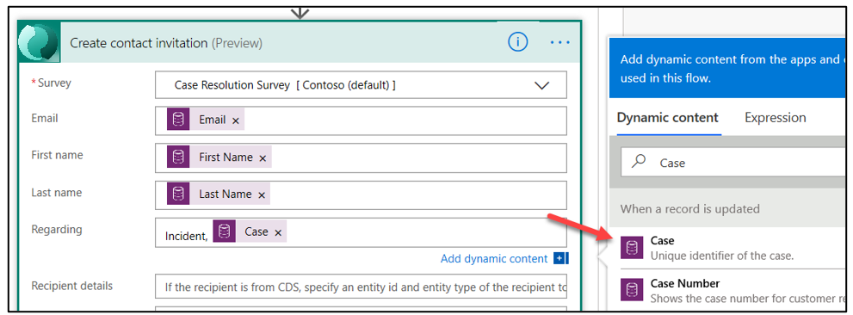

1. Type **Contact** in the **Recipient details** column and select **Contact** from the **Dynamic content** pane.

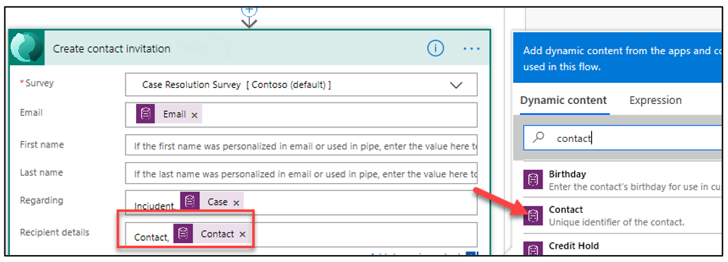

The invitation should now look like the following image.

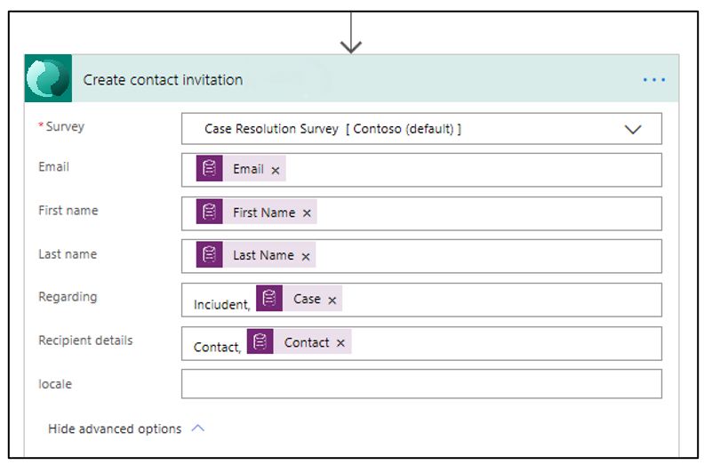

1. Save your progress by selecting the **Save** button.

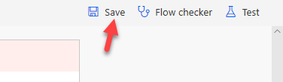

1. Do not navigate away from this page.

## Task 7: Send email

In this task, you will create a **Send email** action that will send the survey invitation.

1. Return to the **If no** path and select **Add an action**.

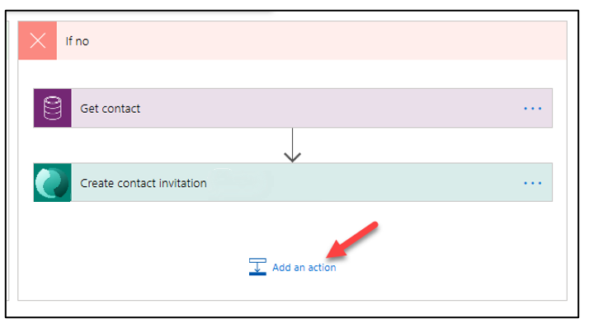

1. Search for **send an email** and select **Send an email (v2)**. If this is the first time that you have used this action, you might need to authenticate. If this connection doesn't work for you, check your user license.

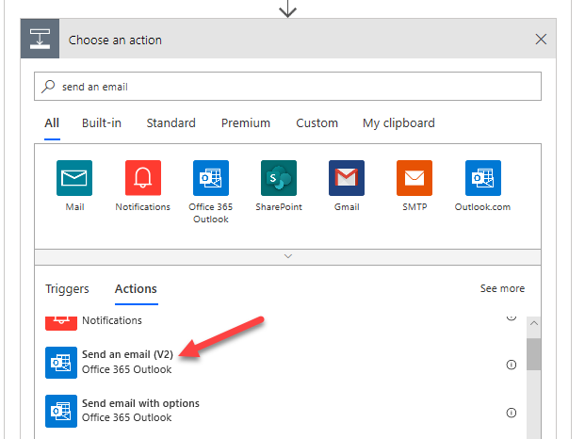

1. Rename the action **Send contact invitation**.

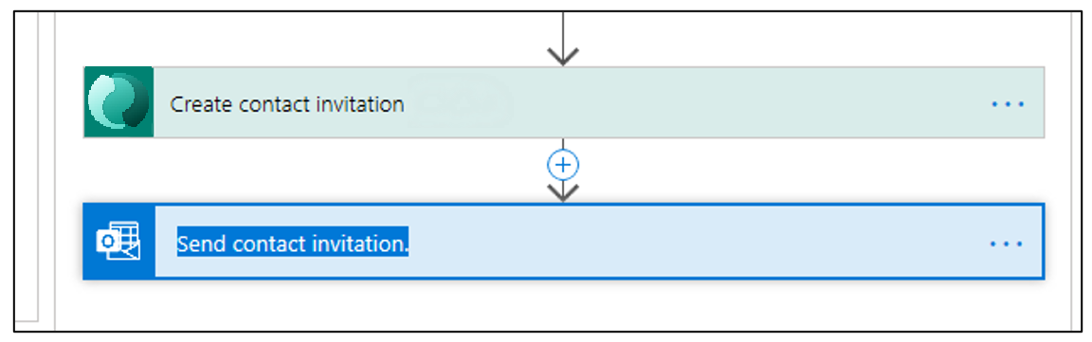

1. Select the **To** column and select **Email** from the **Dynamic content** pane.

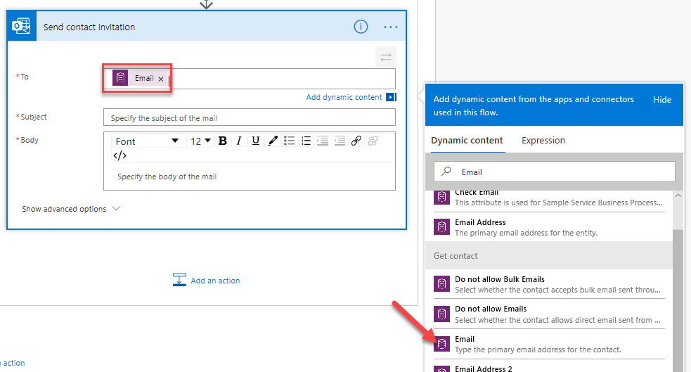

1. Type **Resolved:** and select **Case Title** from the **Dynamic content** pane.

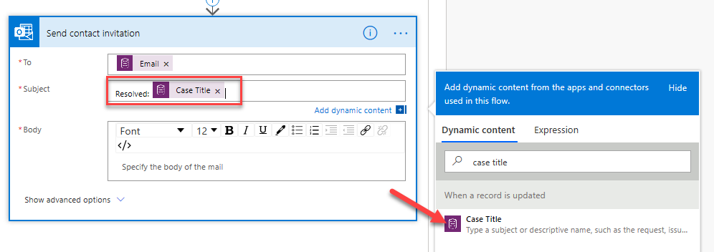

1. Type **Hello** in the **Body** column and select **First Name** from the **Dynamic content** pane.
2. Add a **comma** after the first name and press the **Enter** key twice.
3. Type **We recently resolved the following case for you:** and then press the **Enter** key.
4. Type **Case Number:** and select **Case Number** from the **Dynamic content** pane. Press the **Enter** key.
5. Type **Case Title:** and select **Case Title** from the **Dynamic content** pane. Press the **Enter** key twice.
6. Enter **In order to provide the best quality service to you, please take few moments to let us know how we did.** Press the **Enter** key twice.
7. Switch to **Code View** by selecting the **</>** button.

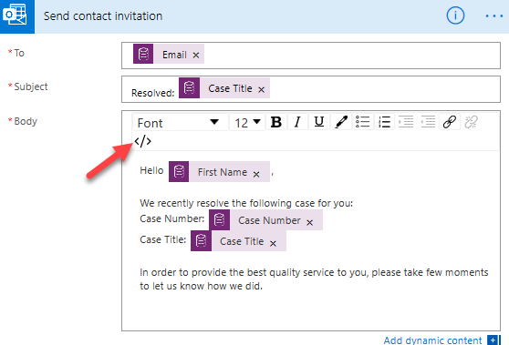

1. Enter **<a href="">Complete Feedback Survey</a>** and then place your cursor between the two double quotation marks.

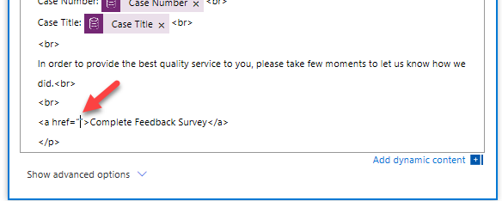

1. Select **Invitation link** from the **Dynamic content** pane.

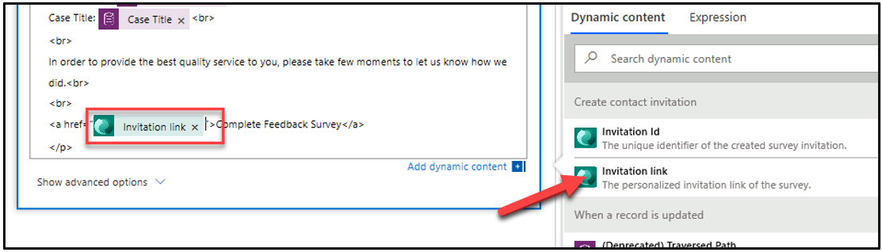

1. Type **<br> <br>** and then press the **Enter** key.
2. Type **Thanks for your business <br><br>**.

Your email should now look like the following image.

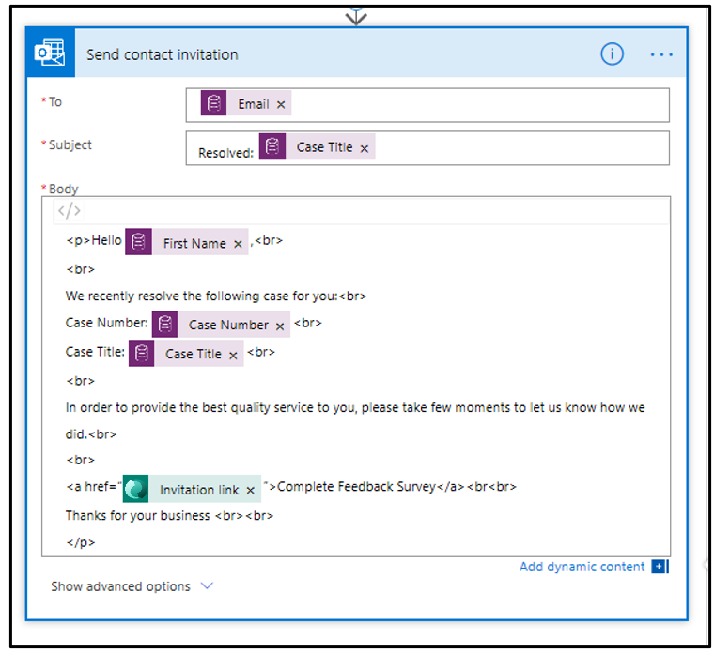

1. Select **Save**.

## Task 8: Test the send survey invitation

In this task, you will test the send survey invitation flow.

1. Go to your Dynamics 365 **Sales Hub** application.
2. Select **Cases** and select to open the case that you created.

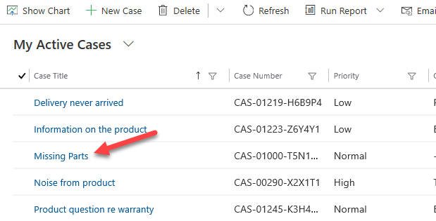

1. Select **Resolve Case**.

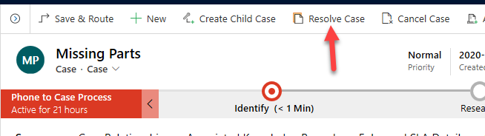

1. Enter **Sent replacement parts** for **Resolution**, select **30 minutes** for **Billable Time**, and select **Resolve**.

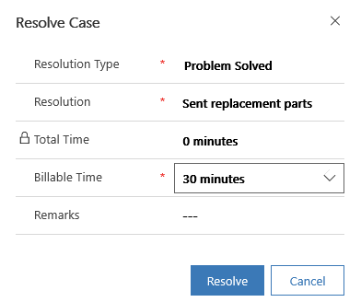

You should get an email from the flow.

1. Select to open the email.

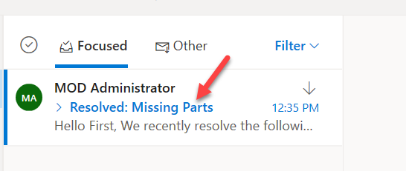

1. Your survey invitation email should look like the following image. Select the survey link.

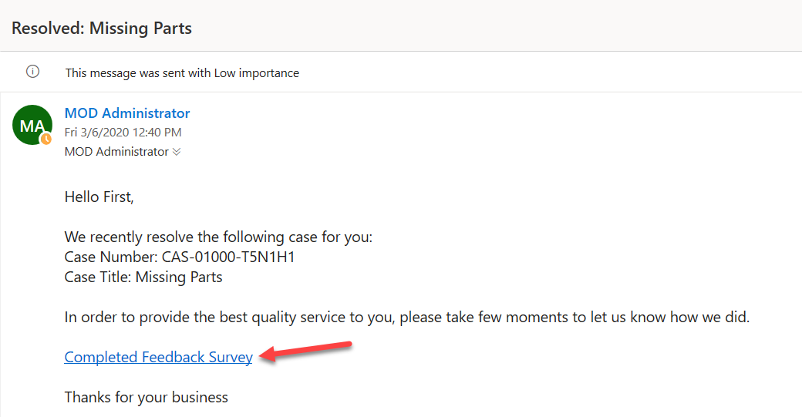

The survey should load.

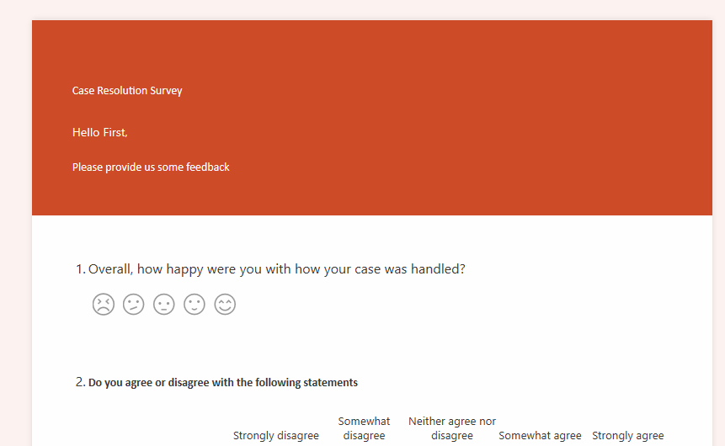

1. Close the survey browser window or tab.